**Creating the Firebase Project (to generate googleservices.json):**1. Create a firebase project

Adding Sha-1 fingerprint:

=> In the project folder : Go to android folder cd android

=> Generate the Sha1 key using : ./gradlew signingReport

=> Add the Sha1key to the firebase project and click next, then the googleservices.json can be downloaded, and then at the app level of the project ( at /android/app/googleservices.json)

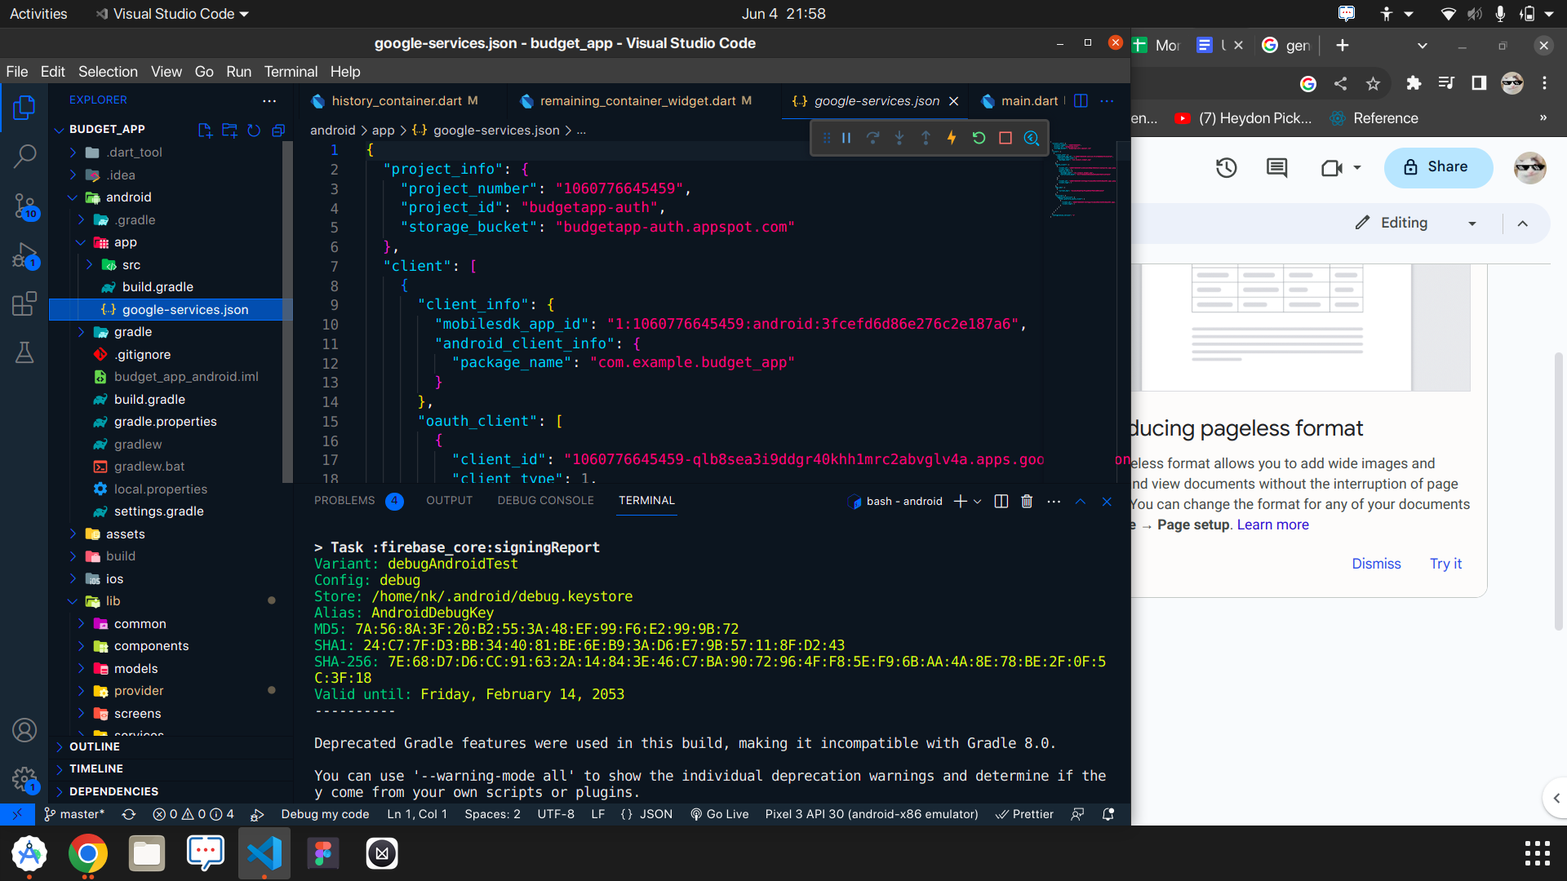

2. Add Firebase SDK

To make the google-services.json config values accessible to Firebase SDKs, you need the Google services Gradle plugin.

Add the plugin as a buildscript dependency to your project-level build.gradle file:

Root-level (project-level) Gradle file (<project>/build.gradle):

buildscript {

repositories {

// Make sure that you have the following two repositories

google() // Google's Maven repository

mavenCentral() // Maven Central repository

}

dependencies {

...

// Add the dependency for the Google services Gradle plugin

**classpath 'com.google.gms:google-services:4.3.15'**

}

}

allprojects {

...

repositories {

// Make sure that you have the following two repositories

google() // Google's Maven repository

mavenCentral() // Maven Central repository

}

}

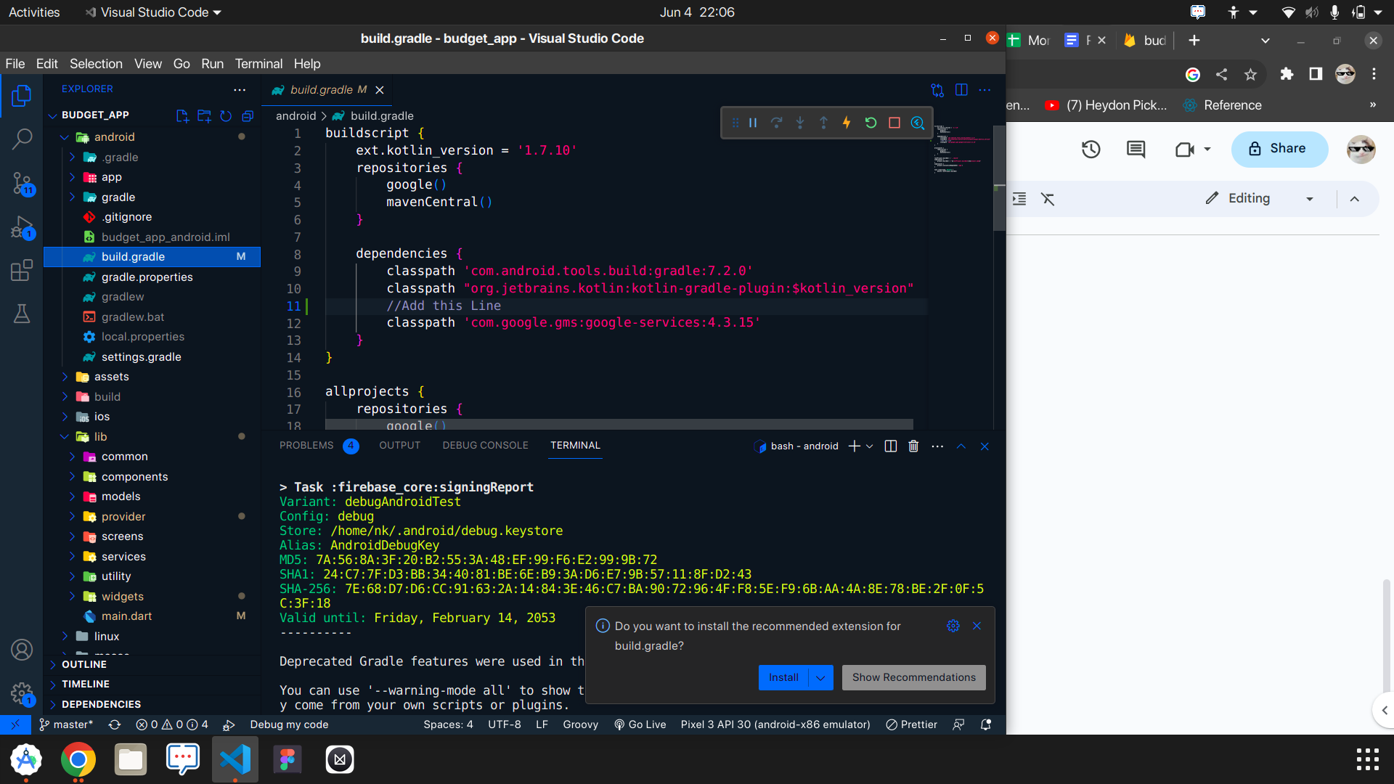

Then, in your module (app-level) build.gradle file, add both the google-services plugin and any Firebase SDKs that you want to use in your app:

Module (app-level) Gradle file (<project>/<app-module>/build.gradle):

apply plugin:’com.android.application’

apply plugin:'com.google.gms.google-services'

dependencies {

// Import the Firebase BoM

implementation platform('com.google.firebase:firebase-bom:32.1.0')

}

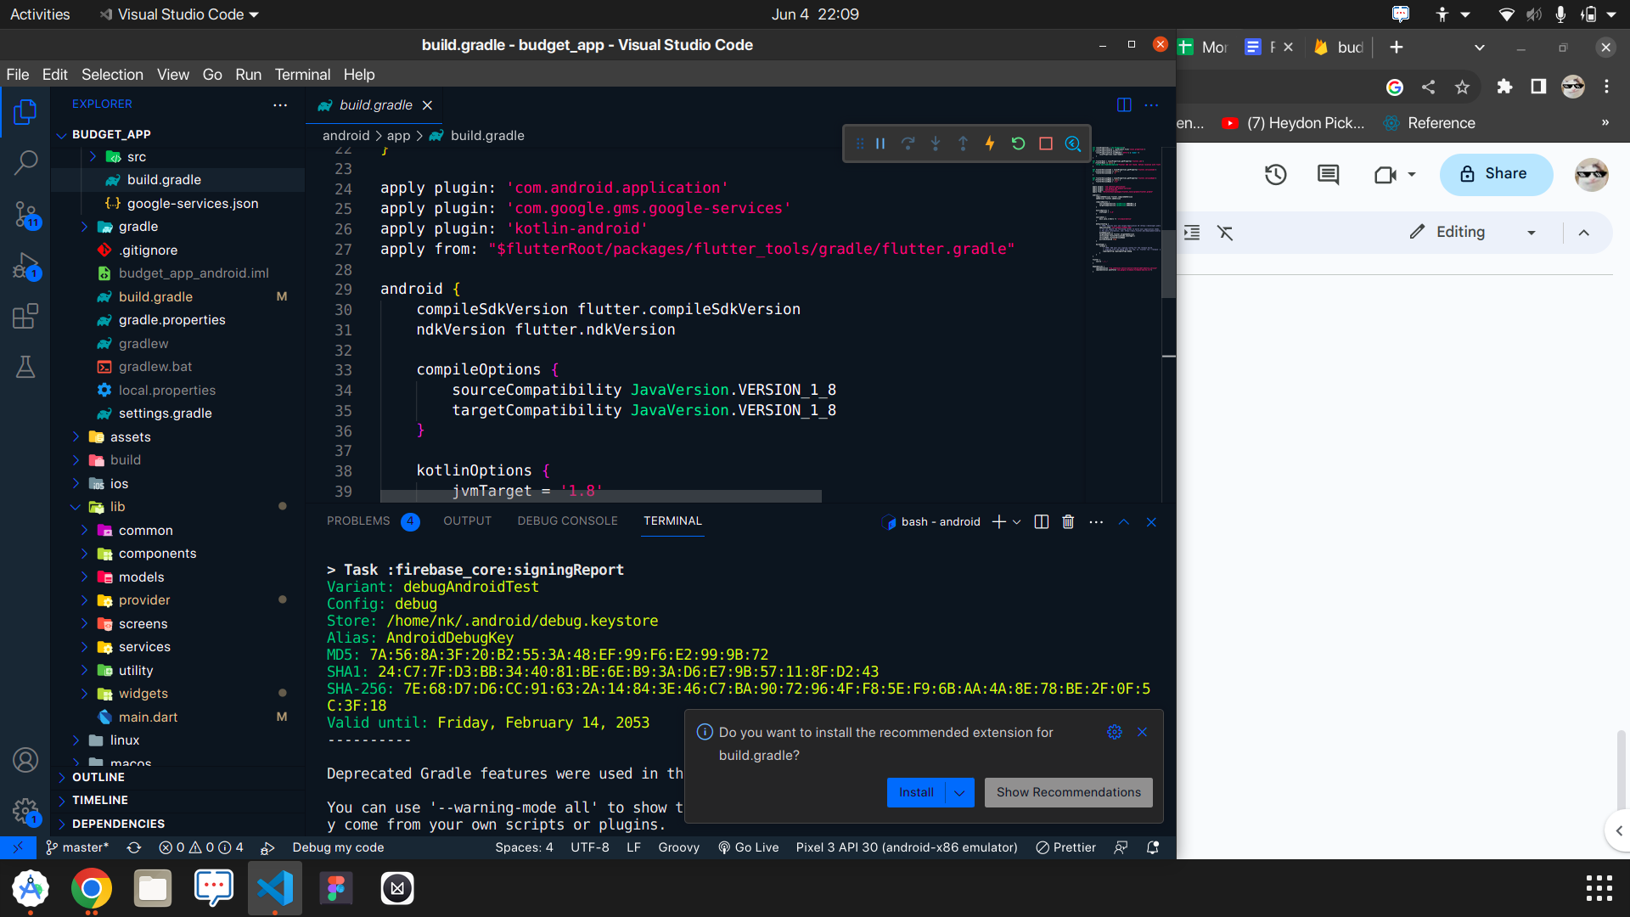

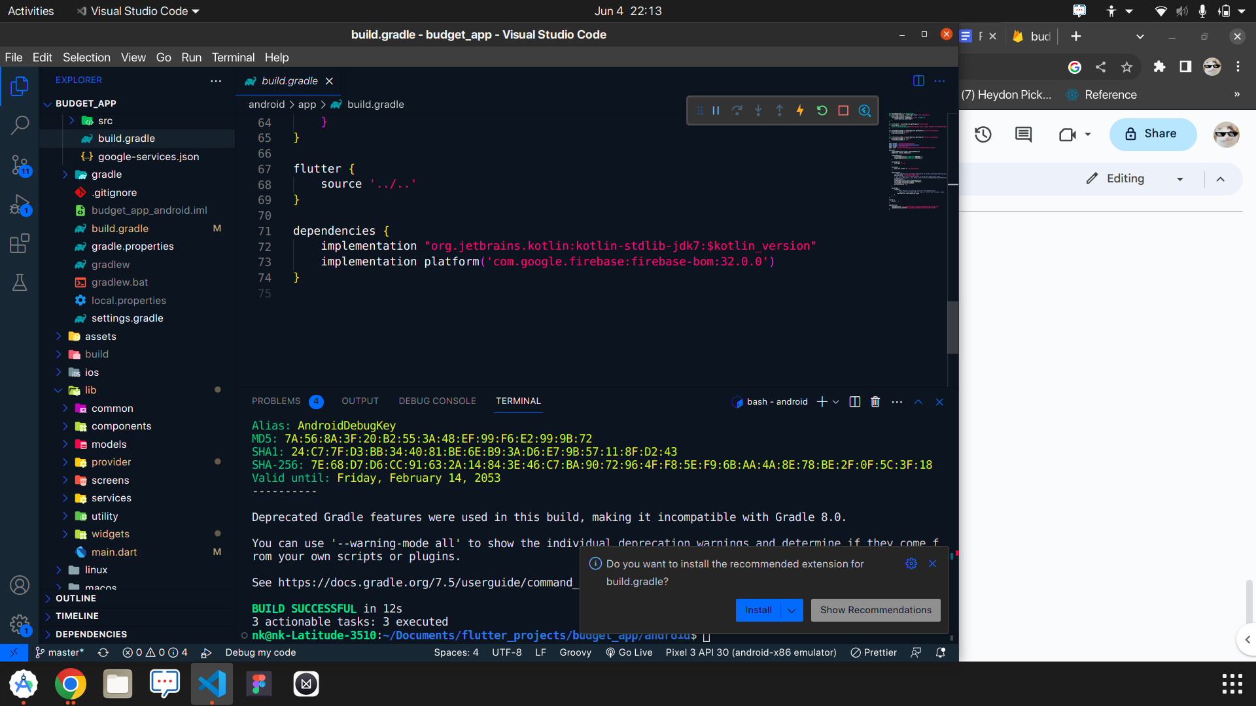

In the same file(/android/app/build.gradle), make sure to edit these lines

**minSdkVersion 21**

**multiDexEnabled true**

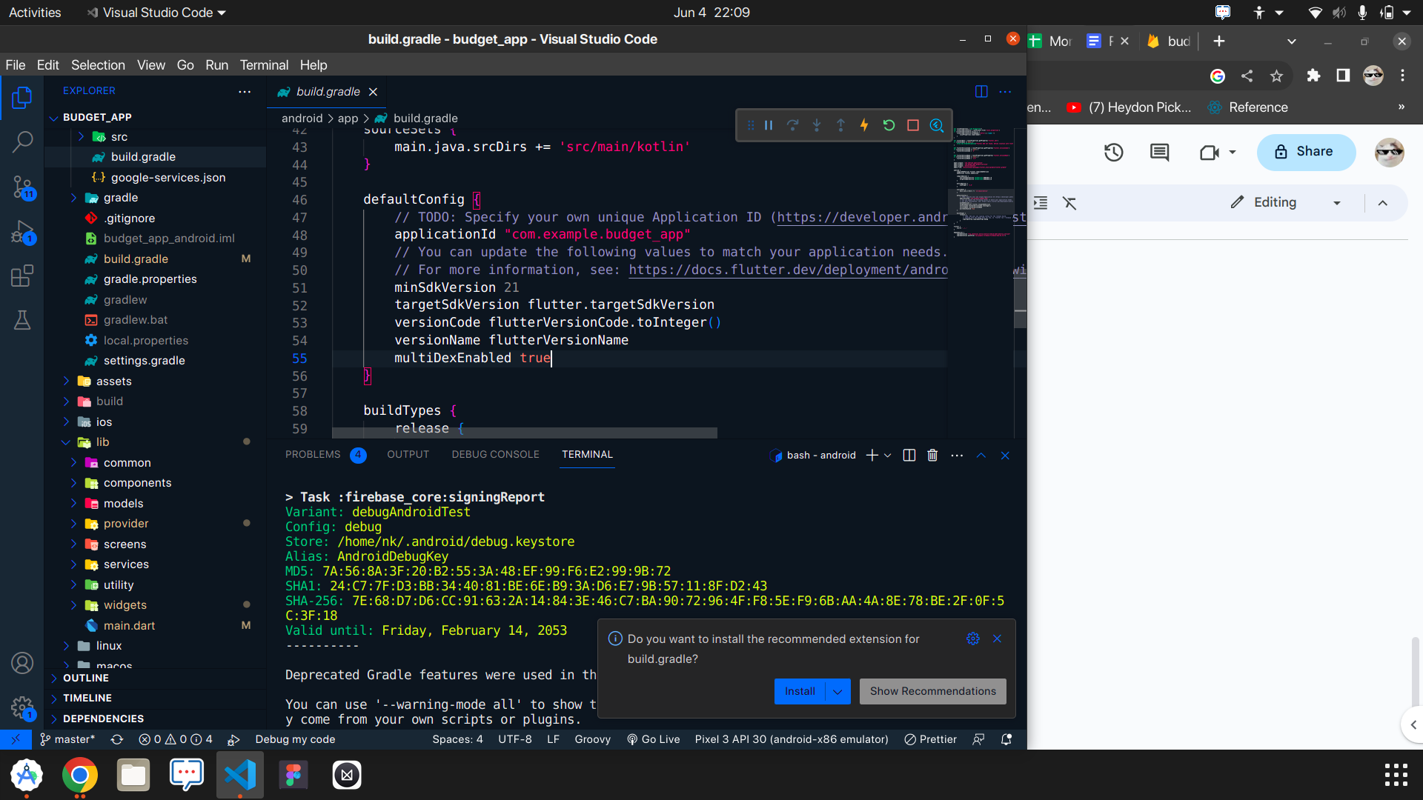

In the path “android/app/src/main/AndroidManifest.xml”

Add the line in the manifest file:

<uses-permission android:name="android.permission.INTERNET" />

You can edit the app name using the android:label =”Your App Name”

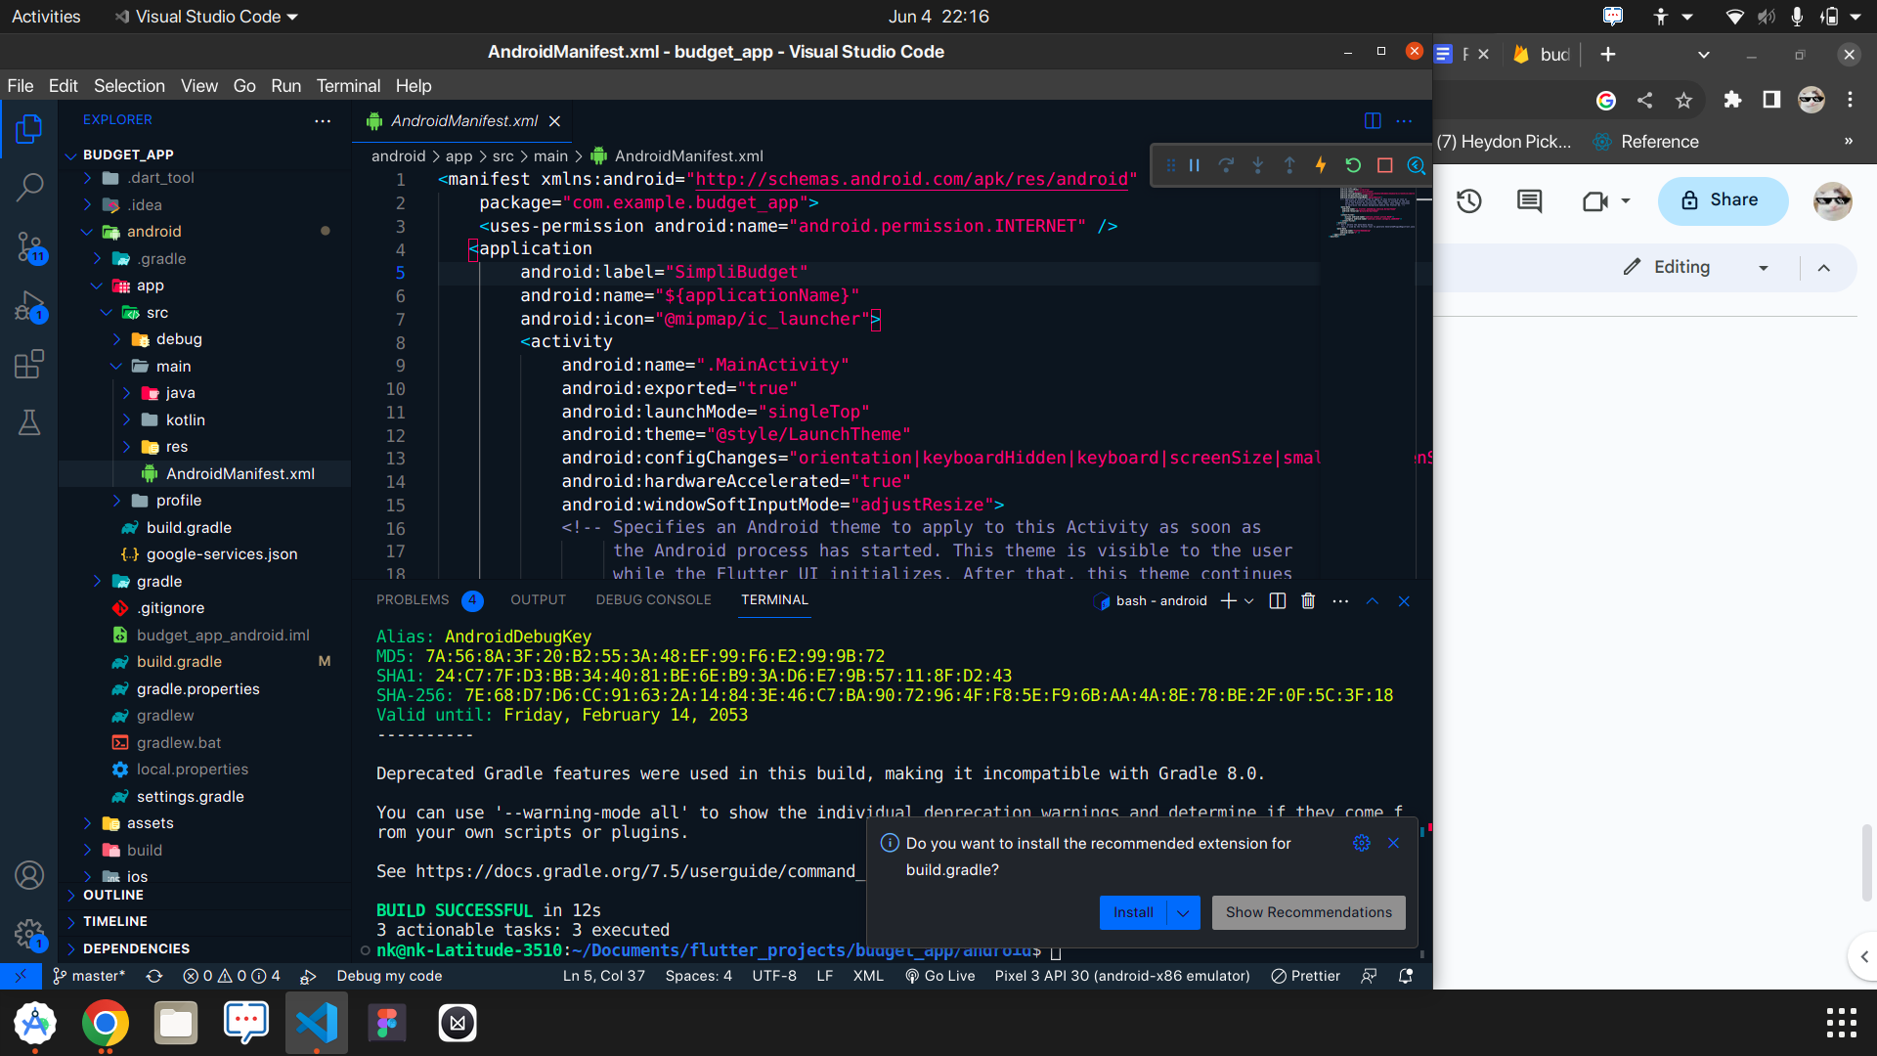

**ENVIRONMENT VARIABLES:**

You can use the .env file and add the following:

SERVER_URL = “your server url goes here”

CURRENCY = “₹”

**To edit the color of the application:**

Use the “lib/common/color_schemes.dart”

=> primary:

=> secondary:

=> tertiary:

You can edit these colors in the lightColorScheme

**To change the app icon:**

Go to the path “android/app/src/main/res”

And replace all the mipmap folders (mipmap-hdpi, mipmap-mdpi, mipmap-xhdpi, mipmap-xxhpdi) with the new folders that are provided to you in the “assets/appicon”